Slide 3
Project management is the discipline of planning, organizing, securing, and managing resources to achieve specific goals. A project is a temporary exercise with a defined beginning and end (usually time-constrained, and often constrained by funding or deliverables),^{[1]} aimed at meeting unique goals and objectives. The temporary nature of projects stands in contrast with business as usual (or operations),^{[3]} which are repetitive, permanent, or semi-permanent functional activities to produce products or services. In practice, the management of these two systems is often quite different, and as such requires the development of distinct technical skills and management strategies.
The primary challenge of project management is to achieve all of the project goals and objectives while overcoming the preconceived constraints. Typical constraints are scope, time, and budget. The secondary—and more ambitious—challenge is to optimize the allocation and integrate the inputs necessary to meet pre-defined objectives.

Slide 4

Extreme project management
In critical studies of project management it has been noted that several PERT based models are not well suited for the multi-project company environment of today.^{[citation needed]} Most of them are aimed at very large-scale, one-time, non-routine projects, and currently all kinds of management are expressed in terms of projects.
Using complex models for "projects" (or rather "tasks") spanning a few weeks has been proven to cause unnecessary costs and low maneuverability in several cases^{[citation needed]}. Instead, project management experts try to identify different "lightweight" models, such as Agile Project Management methods including Extreme Programming for software development and Scrum techniques.
The generalization of Extreme Programming to other kinds of projects is extreme project management, which may be used in combination with the process modeling and management principles of human interaction management.

Agile project management
Agile project management approaches based on the principles of human interaction management are founded on a process view of human collaboration. This contrasts sharply with the traditional approach. In the agile software development or flexible product development approach, the project is seen as a series of relatively small tasks conceived and executed as the situation demands in an adaptive manner, rather than as a completely pre-planned process.

Slide 5

Traditionally, project management includes a number of elements: four to five process groups, and a control system. Regardless of the methodology or terminology used, the same basic project management processes will be used. Major process groups generally include
- initiation
- planning or development
- production or execution
- monitoring and controlling
- closing
In project environments with a significant exploratory element (e.g., research and development), these stages may be supplemented with decision points (go/no go decisions) at which the project's continuation is debated and decided. An example is the stage-gate model.

The initiating processes determine the nature and scope of the project.
After the initiation stage, the project is planned to an appropriate level of detail (see example of a flow-chart).^{[19]} The main purpose is to plan time, cost and resources adequately to estimate the work needed and to effectively manage risk during project execution
Executing consists of the processes used to complete the work defined in the project plan to accomplish the project's requirements. Execution process involves coordinating people and resources, as well as integrating and performing the activities of the project in accordance with the project management plan.
Monitoring and controlling consists of those processes performed to observe project execution so that potential problems can be identified in a timely manner and corrective action can be taken, when necessary, to control the execution of the project
Closing includes the formal acceptance of the project and the ending thereof. Administrative activities include the archiving of the files and documenting lessons learned.
Slide 6

Project management triangle
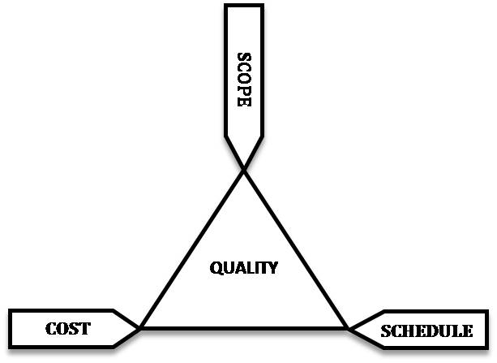
The time constraint refers to the amount of time available to complete a project. The cost constraint refers to the budgeted amount available for the project. The scope constraint refers to what must be done to produce the project's end result. These three constraints are often competing constraints: increased scope typically means increased time and increased cost, a tight time constraint could mean increased costs and reduced scope, and a tight budget could mean increased time and reduced scope.

Slide 7
A part of improvisation

Slide 8
THANK YOU GOD, I HAVE FINISHED!!

